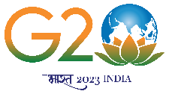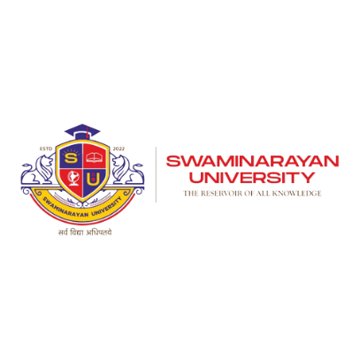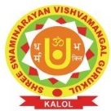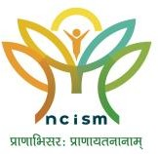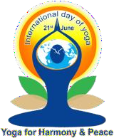**आय मंत्रालय**

**Ministry of AYUSH**

Report of

SURYANAMASKARA

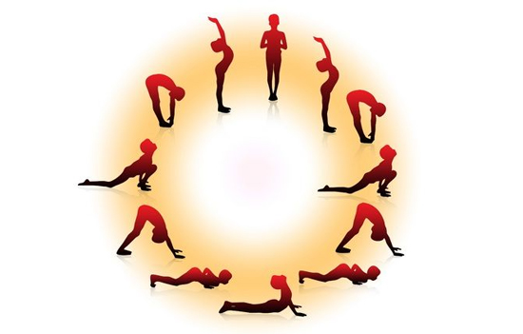

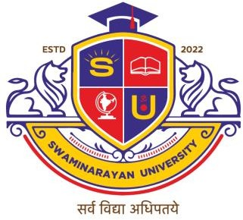

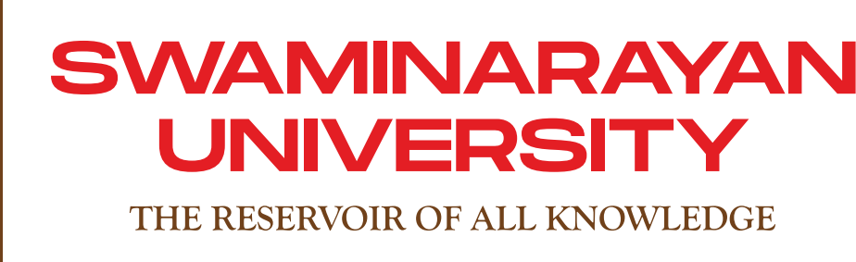

**FACULTY OF AYURVEDA**

**Promoted by: Shree Swaminarayan Vishvamangal Gurukul**

Ahmedabad-Mehsana highway, At & PO. Saij, Kalol

## SURYANAMASKARA

As part of International Day of Yoga, Suryanamaskara Session was conducted on 17th June 2023 by Swaminarayan University. 407 participants took benefit of this event. Event was co ordinated by Dr. Ayana R and guest Mr. Jitendra Jani, Yoga practitioner conducted the session

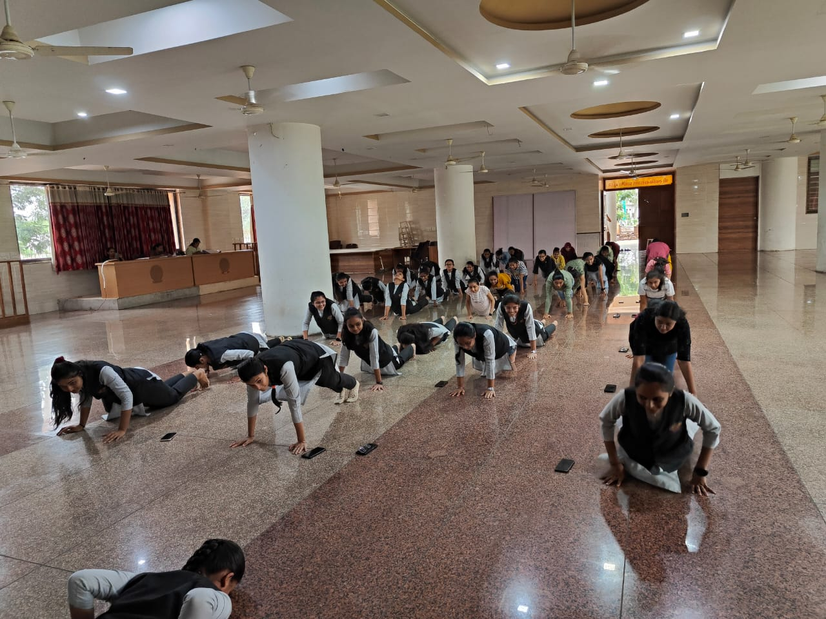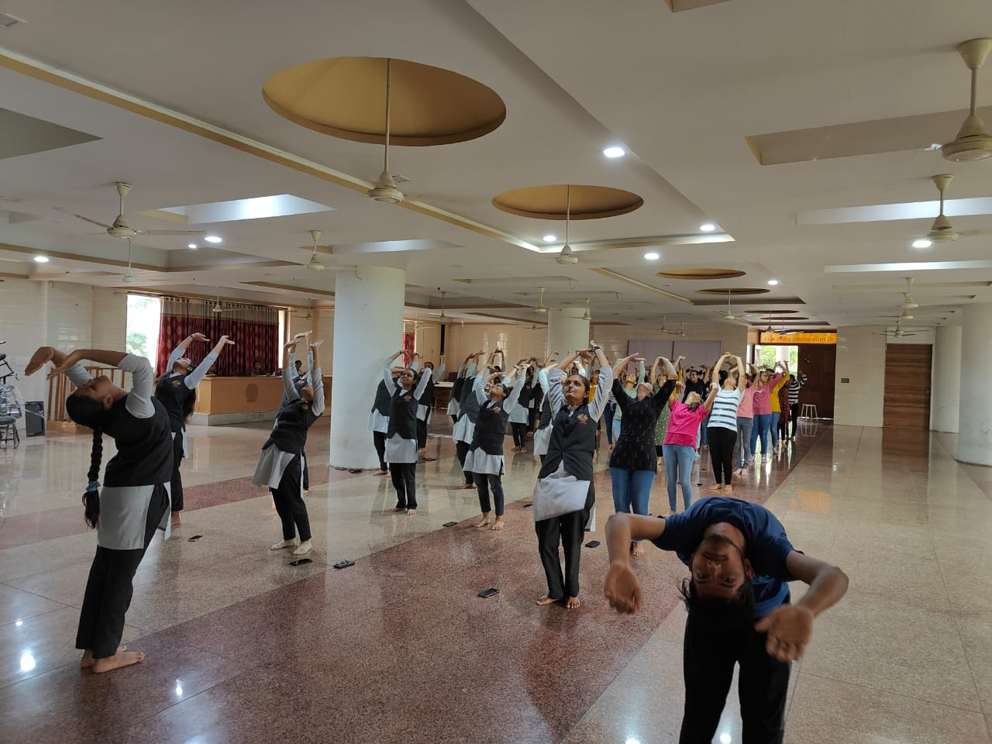

**FACULTY OF AYURVEDA**

**Promoted by: Shree Swaminarayan Vishvamangal Gurukul**

Ahmedabad-Mehsana highway, At & PO. Saij, Kalol